|  |  |  |
| --- | --- | --- |
|  | |  |
| Name: Muhammad Ali | Roll No: 21L-5463 | |
| Course: Quantum Computing | Section: 6A2 | |
| Date: | Document Name: QC_Notes | |

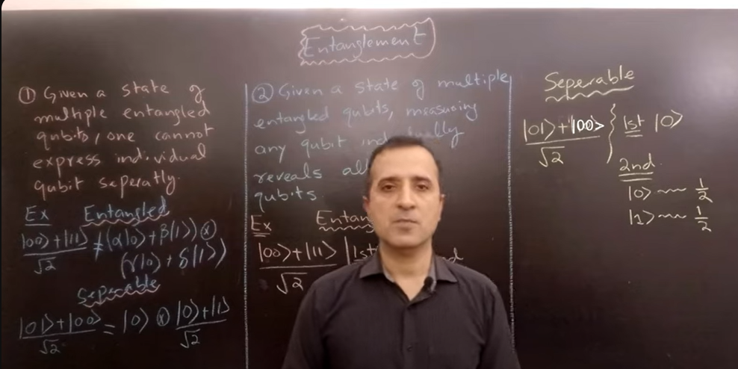

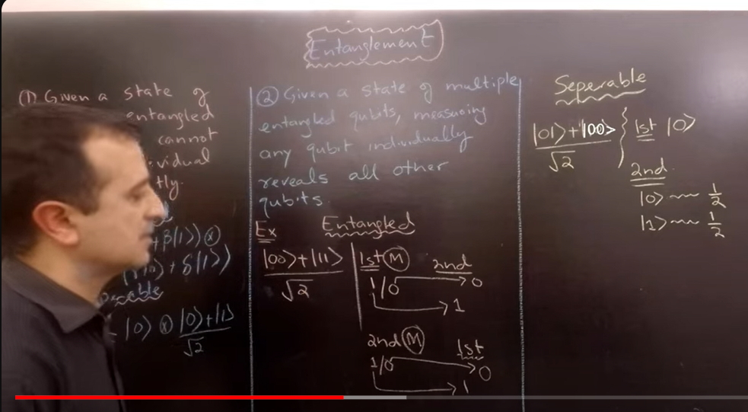

Thes are 4 bell states.

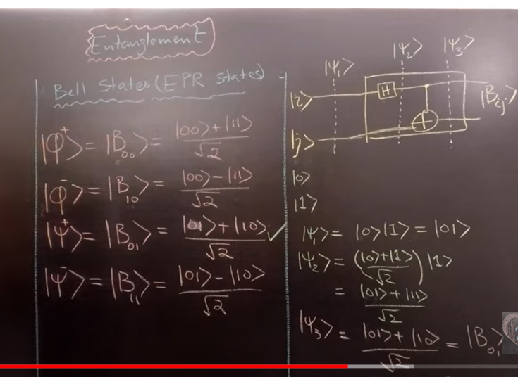

To check qubits are entangled or not.

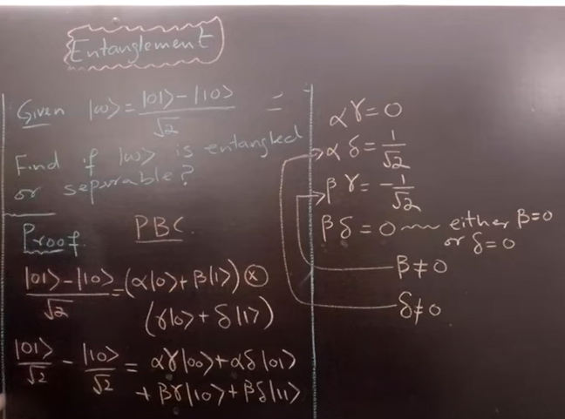

**Quantum Teleportation:**

We send one qubit by actually sending two classical qubits.

1. Alice and bob make a bell state (w3).
2. Alice wants to send message (y = a|0> + b|1>)).
3. Gate applied on w5,6 will be applied on a register where 1st qubit is y (message) and second qubit is first qubit of bell state.
4. In w7, bob applied a gate on his part of bell state, depending on measured values of classical bits he has received.

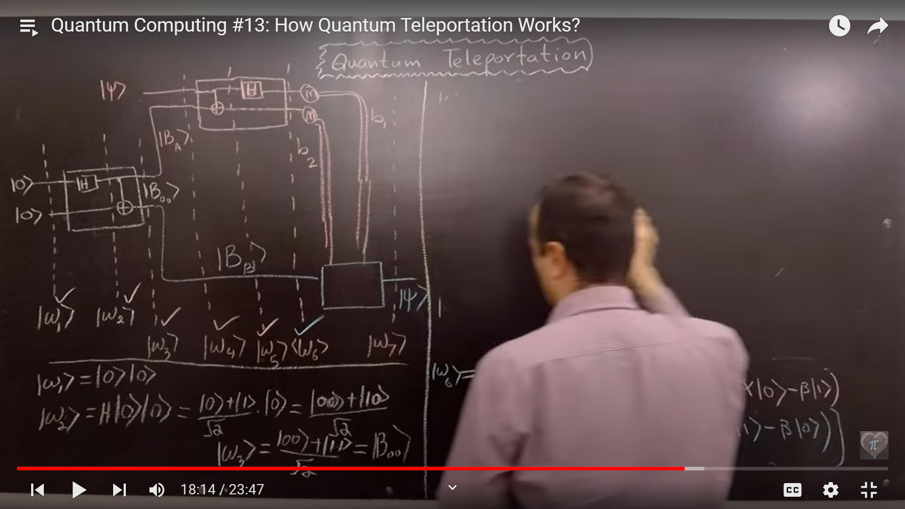

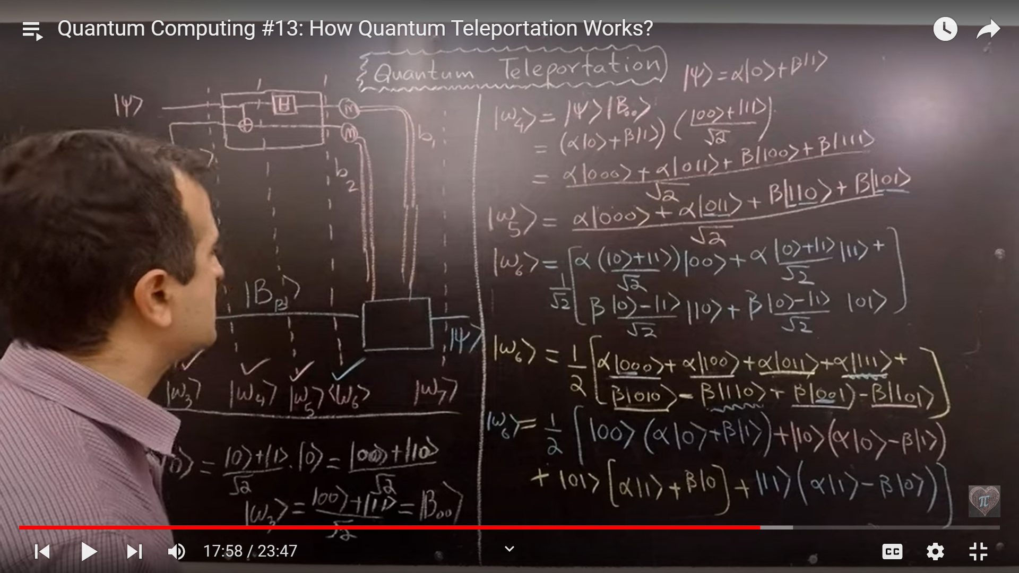

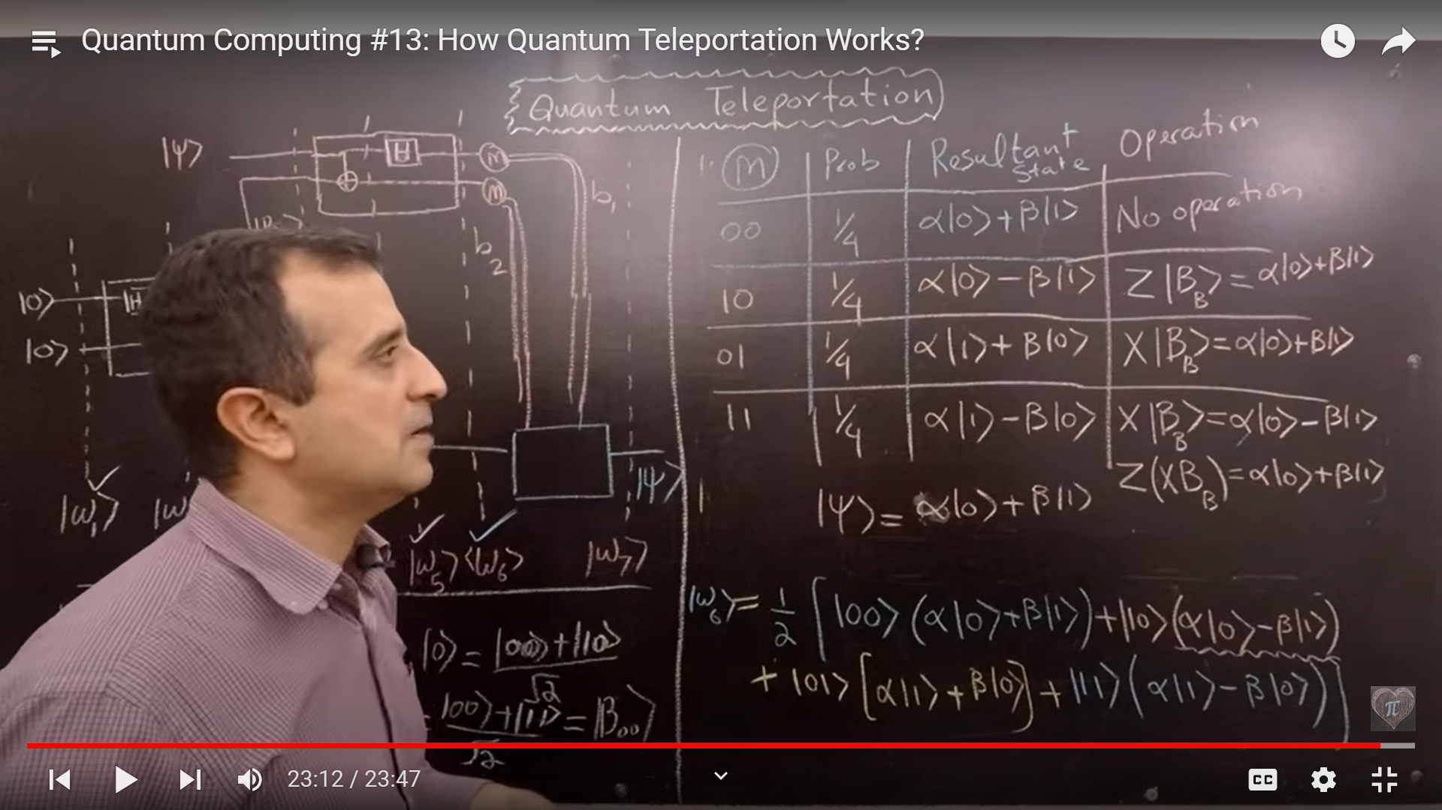

**Superdense Coding:**

We send two classical bits by actually sending one qubit.

1. Bell state is made (w2).
2. Alice apply some gate to first qubit of bell state (his part of bell state), depending on the two classical bits he wants to send. And then send that qubit.
3. now bob apply some gates (cnot and H) on qubit received by alice and he will be able to see the two classical qubits alice has send.

